* 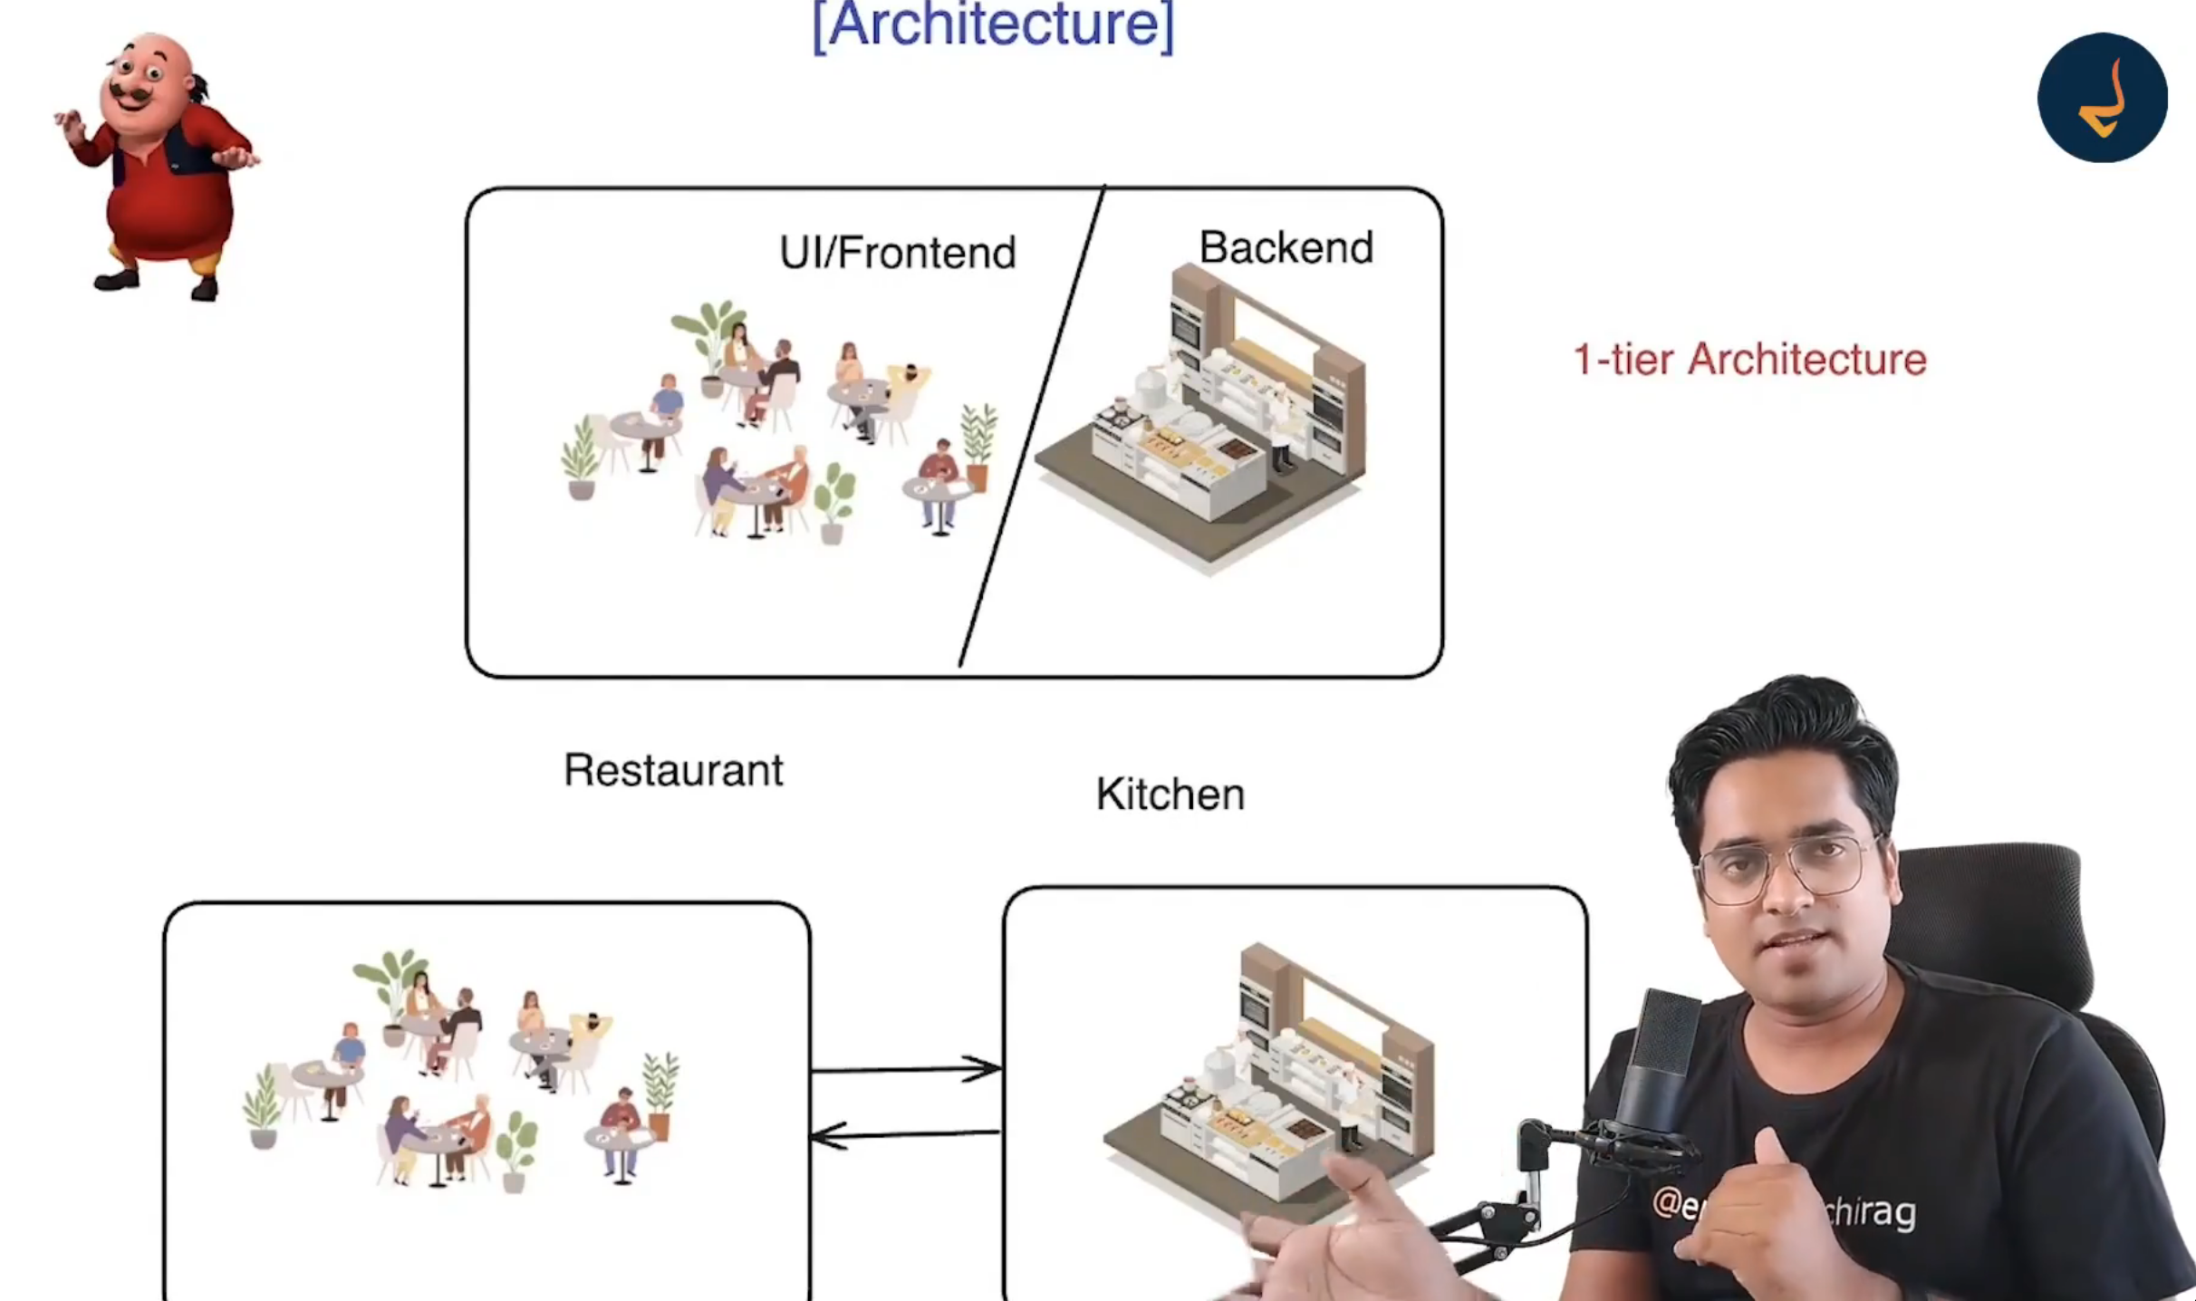
* 1 tier architecture-> BE, FE and database are in same system
* 2 tier architecture -> BE+DB and FE are in different system
* 3 tier architecture -> all are in different system

Rest API

* REST API -> Representational State transfer application programming interface.
* HTTP
  + Hyper text transfer protocol is the set of protocols/rules which are used to send data between client and server.
  + REST is build over HTTP.
* Request
  + 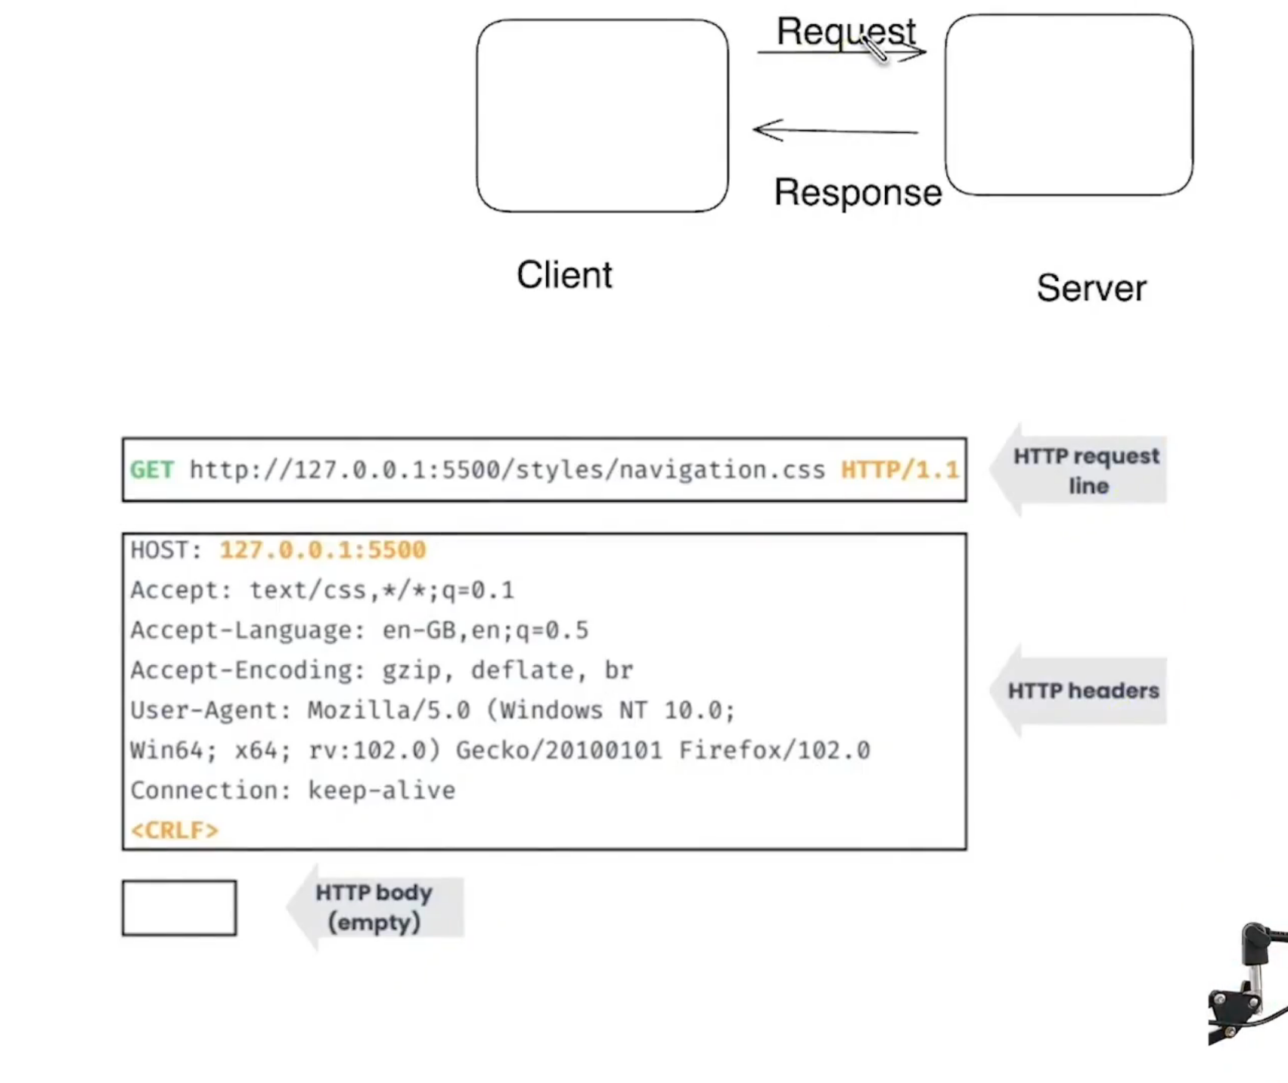
* Response
  + 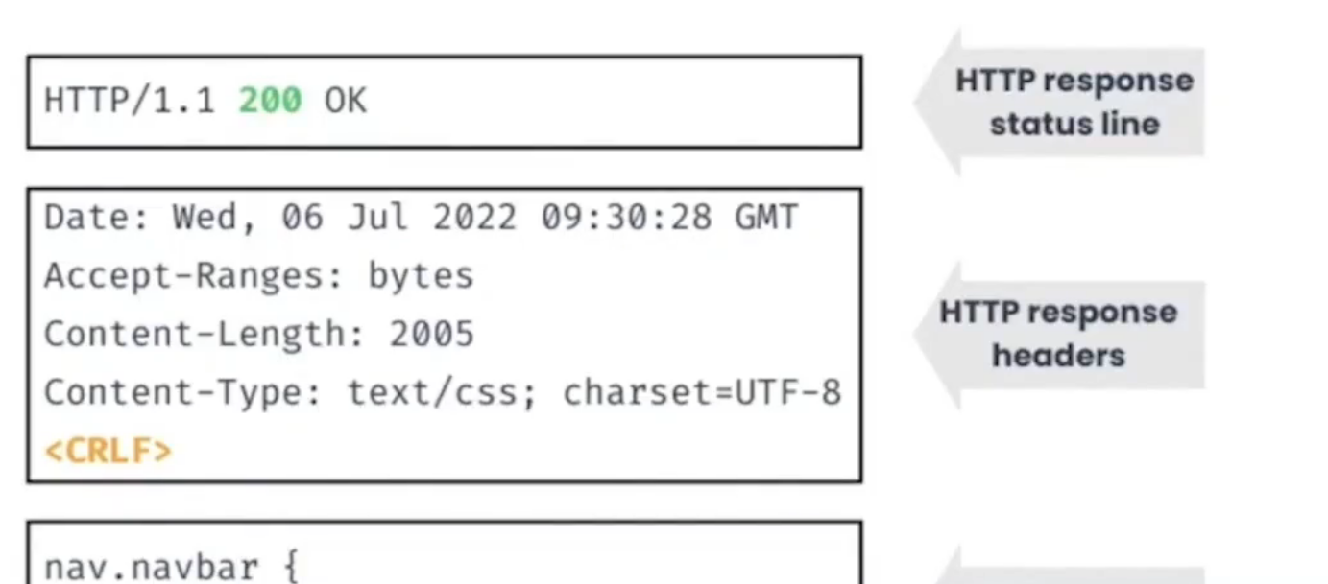
* 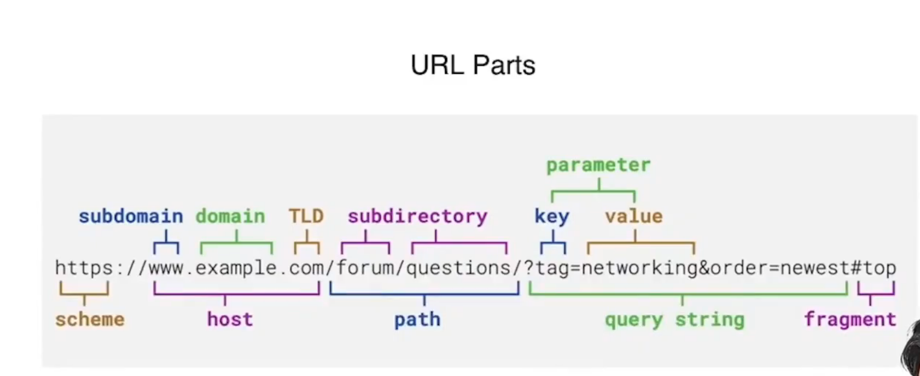
  + Fragment or anything after # is not passed from client to server.
* HTTP methods -><https://www.theserverside.com/blog/Coffee-Talk-Java-News-Stories-and-Opinions/HTTP-methods>